Backend / AI

“Your Progress” Statistics Are Not Updating
The statistics under Your Progress remain unchanged even when the user is signed in and completes learning activities.
Expected Result:
The progress statistics should update according to the user's completed learning activities.

Study Sheet Is Generated From Invalid or Meaningless Input
When the user enters meaningless/unrelated text, the system still generates a study sheet for an inferred topic instead of handling the invalid input.
Expected Result:
The system should not confidently generate a study sheet for an unrelated inferred topic. It should ask the user to provide a clearer medical topic or valid notes.
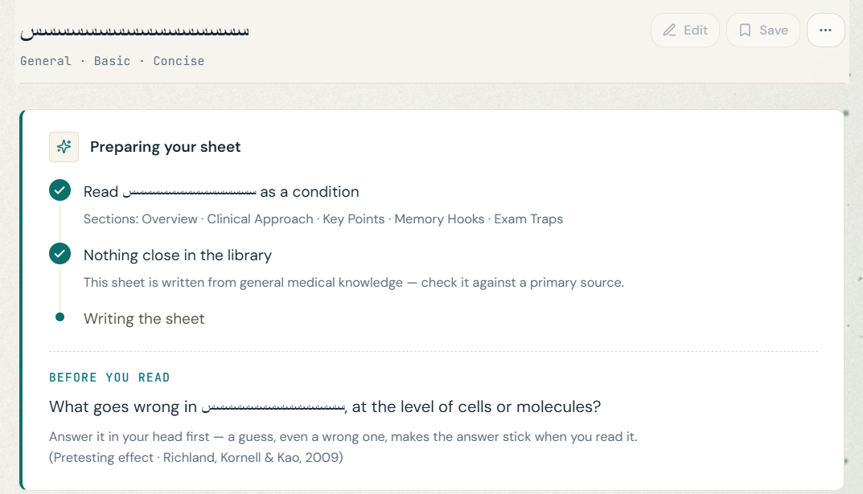

Clinical Scenario Generates an Incomplete Study Sheet
When generating a Study Sheet from a clinical scenario, the system sometimes generates only a one-line diagnosis such as “Congestive heart failure.” and immediately displays End of Sheet, instead of generating the expected Study Sheet sections.
Expected Result:
A successful generation should produce a complete Study Sheet with the expected sections based on the selected settings. If generation fails to produce the required content, the system should show an error/retry state instead of treating a one-line response as a completed Study Sheet.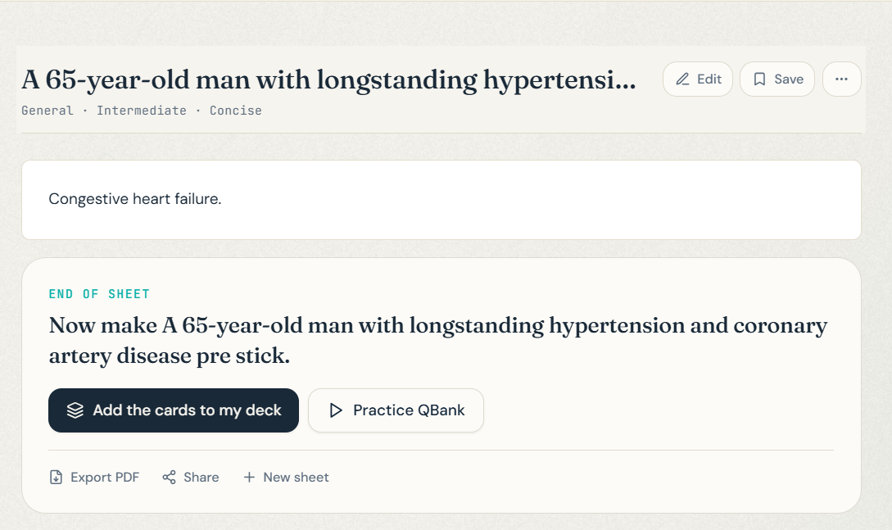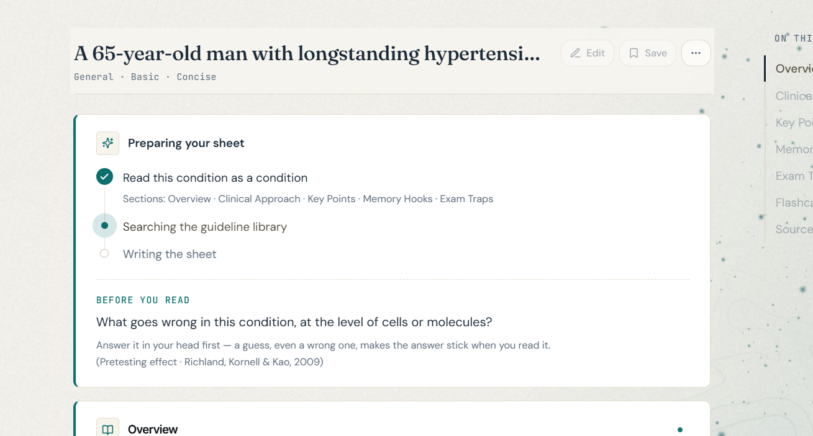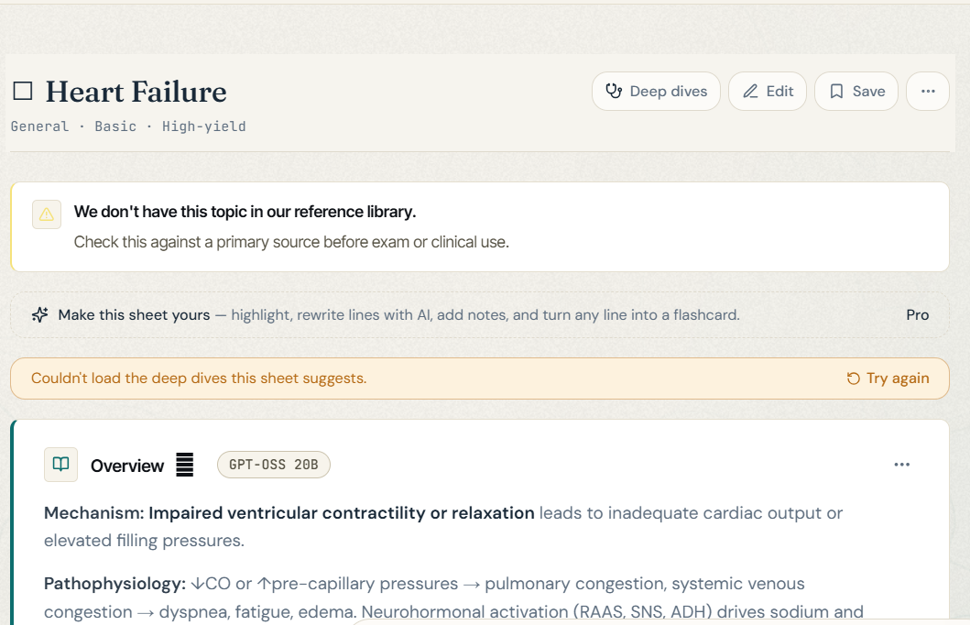

Full-Stack

“Sign in to Track” Is Displayed for Authenticated Users
The Dashboard displays the “Sign in to track” message even when the user is already signed in.
Expected Result:
The message should only be displayed to guest users. Authenticated users should see their progress information without a sign-in prompt.

Practice QBank Authentication Flow Does Not Preserve the Intended Destination
When a guest user clicks Practice QBank from a Study Sheet, the user is redirected to the Dashboard instead of the Login page. After the user signs in, they are not returned to the intended QBank session and must restart the flow manually.
Expected Result:
Clicking Practice QBank as a guest should redirect the user to the Login page. After successful authentication, the user should automatically continue to the intended QBank session while preserving the Study Sheet/topic context.

Saved Flashcard State Is Not Preserved After Reopening a Study Sheet
After adding a flashcard, saving the sheet, and reopening it from the Library, the flashcard appears as available to add again even though it is already saved. Clicking Add displays a success message, but no new card is actually created.
Expected Result:
Previously saved flashcards should remain marked as saved after reopening the sheet. The Add action should be disabled or indicate that the card is already saved.

Unnecessary Save Button on Saved Sheets in Library
The Save button remains active when viewing an already saved, non-editable Study Sheet from the Library. Clicking Save again increases the saved sheet count even though no new sheet or changes were created.
Expected Result:
The Save button should not be displayed for an already saved, non-editable Study Sheet, and re-saving the same sheet should not increase the saved sheet count.

Frontend / UI / UX

Pro Banner Close Button Is Not Working
The close button on the Pro promotional banner does not dismiss the banner when clicked.
Expected Result:
Clicking the close button should dismiss the Pro banner.

Static “SESSION 01” Label on Dashboard
The Dashboard always displays “SESSION 01”, but the value does not change or represent an actual user session.
Suggestion:
Remove the label if it has no purpose, or make it dynamic if it is intended to represent the user's current session.

Roadmap Page Is Not Properly Responsive on Mobile
The Roadmap page layout is not properly optimized for mobile screen sizes and requires responsive UI adjustments.

Roadmap State Is Not Preserved on Back Navigation
Suggestion:
When users return to the Roadmap after opening a topic, preserve the previously selected system, search/filter state, and scroll position instead of returning them to the default Roadmap view.
Possible Improvement:
Consider reflecting the selected system in the URL (e.g. /roadmap?system=cardiovascular) to support back/forward navigation, refresh, and shareable states.

Flashcard “Show All” State Is Not Synchronized With Individually Revealed Cards
If a flashcard answer is revealed individually and the user then clicks Show All, that card does not synchronize correctly with the global Show All/Hide All state.
Expected Result:
Show All / Hide All should apply consistently to every flashcard, regardless of whether a card was previously revealed individually.

Preset Topics Start Generation Before Users Can Configure Settings
Selecting a suggested/preset topic immediately starts generating the Study Sheet, preventing users from adjusting generation settings such as difficulty, length, sources, etc.
Expected Result:
Selecting a preset topic should populate the topic field first and allow the user to review or change the generation settings before clicking Generate.
Suggestion:
Consider providing two flows for preset topics: Quick Generate for immediate generation using the current/default settings, and Customize First to select a topic, adjust the generation settings, and manually start generation.

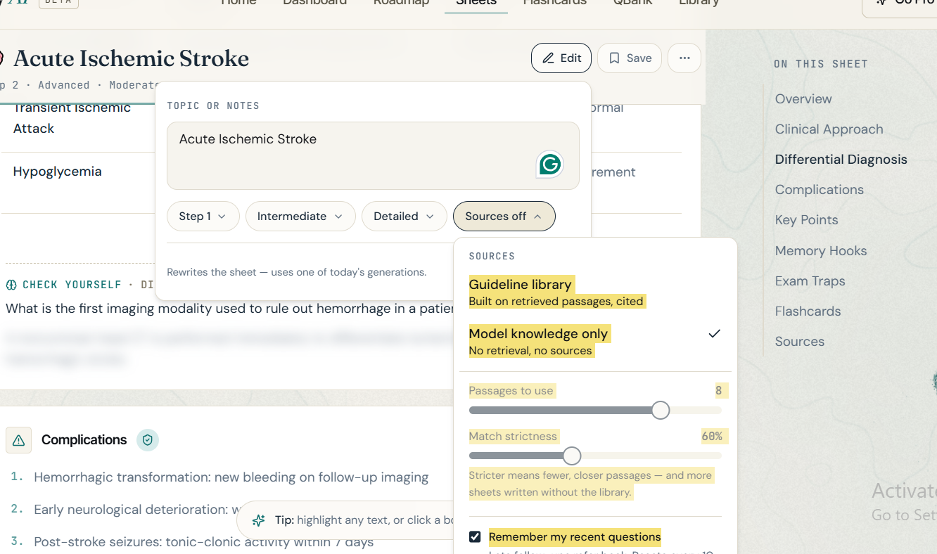

AI Model Names Should Not Be Displayed to Users
The AI model name is displayed in the interface even though users cannot interact with or change it.
Suggestion: Hide the model name unless it provides meaningful information or functionality to the user.

Newly Generated Study Sheets Do Not Appear in Recent Sheets
After generating a new Study Sheet, it does not appear in Recent Sheets. This happens for both anonymous and logged-in users, whether the sheet is saved or not.

Login Redirects Users to the Landing Page
When an anonymous user logs into an existing account while using the website, they are redirected to the landing page instead of returning to the page they were using before login.
Expected Result:
After logging in, the user should remain on the same page and be able to continue their activity.

Flashcard Review Page Has No Exit or Back Option
Opening a flashcard deck from Library takes the user to the review page, but there is no Back or End Session option.
Expected Result:
Provide a clear option to leave the review and return to Library.

